Phone Number : +919461234552 and Same Whatsapp .

Address : Attached in a company letter

Company Name : Attached in Letter

Mail id : [ceo@tuzech.com](mailto:ceo@tuzech.com)

Social Presence

Linkedin Link : <https://www.linkedin.com/in/hardik-bansal-7945a5a2/>

Fiverr Link : https://www.fiverr.com/users/tarilade/

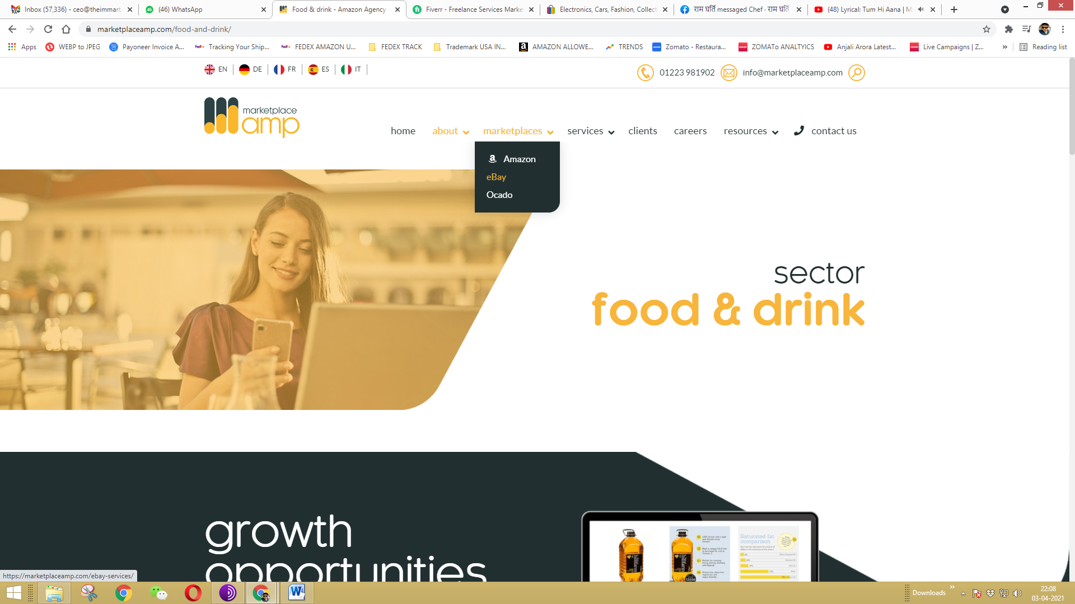

Marketplace – Amazon / Ebay / Etsy / Walmart

Clients – Add existing , and add more which are specified in The Portfolio

Remove Blogs in resources

Remove Linnworks , DSP , Packshot photography , Sales amplifier in services

Marketplace AMP is his website name , Replace the Same with Immart Advisors .

### welcome to **amp!**

We’re the UK’s only FMCG grocery aisle marketplace specialists.

From food and drink essentials, health and beauty must-haves and pet care necessities, we’ve got the grocery aisle covered, so your customers can…

Find, Love and Buy your products on the world’s marketplaces!

Remove this text , and use which is in my portfolio attached .

Also post Cert of Good standing , attached in the mail and UK registration , India Reg and USA reg all GST s .

Screenshots of some clients – use them for any random to showcase , not required to map with any .

Also if you want to add , add some of google and facebook ads field also , if I get any query we wil discuss in future ( in services , but with good photos and all )

Add sourcing And shipping from India – In services

We source and send goods direct to amazon from India , end to end solutions , you need any info regarding this let me know , pictures I can ask my designer to make.